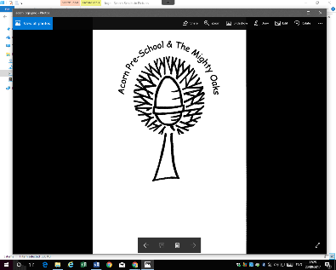

**Mighty Oaks**

**Upcoming**

**Themes**

**Before and After School Club**

Coloring competition week

Cookery Nights



Science Experiments Week



Shrinky Dinks keyrings

W/B 8th January



Tuesday 16th January

Wednesday 31st January

Thursday 22nd February

Monday 5th March

Friday 23rd March

Smoothie Making Week



WB 29th January



W/B 26th March

W/B 19th February

Ink Marbling Week

Farm Visit from Ark Farm

Traditional Games Week

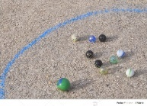

W/B 26th February

Photo Holder Decorating

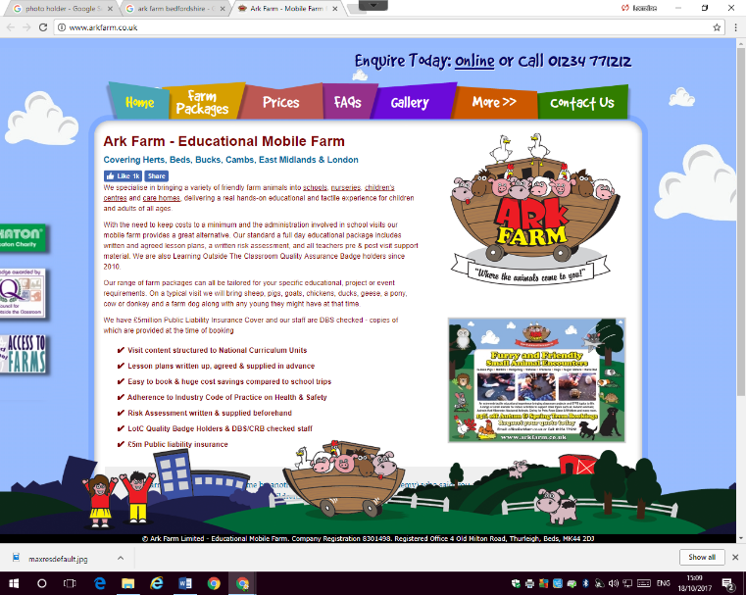



Valentine’s Day Week

W/B 15th January

22nd and 27th March

Further details to be confirmed



Mother’s Day / Special Person Gifts Week

W/B 22nd January

W/B 5th February



Puppet Sewing Week

Planting Week

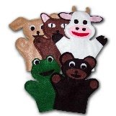

W/B 12th March

W/B 19th March

W/B 5th March